Binned-Profile Model: An Open-Loop Color Correction Approach

to the Color Bending Problem in Optical See-Through Displays

Author 1*

Organization or School

Abstract

Optical see-through displays allow users to view both digital content and physical objects at once. In such displays, light coming from background objects mixes with the light originated in the display, causing what is known as the color blending problem. Color blending negatively affects the usability of optical see-through displays as it impacts the legibility and color encodings of digital content; preventing wider adoption of such technologies. Color correction aims at reducing the impact of color blending by finding an alternative color which, once blended with the background, results in the original color. Existing approaches to color correction are closed-loop, that is, they correct and measure iteratively using a camera from the user’s vantage point.

In this paper we explore an open-loop approach, that is, one where colors are corrected once and without a feedback loop. Our approach is based on two display-induced distortions: (1) each display renders colors differently and (2) background colors are changed by the display medium before blending. We propose the binned-profile (BP) model to address the first distortion and studied it with an extensive set of colors on different displays devices. For a given display the model uses a colorimetric profile of how such display renders colors; with colors binned to a small set of “noticeably different” colors. We validate our model by measuring how accurately it predicts color blending as compared to other prediction models. Then, we introduce a color correction algorithm and measure its correction capacity for different sets of background and foreground colors. Results show the BP model can accurately predict color blending within 9 just noticeable differences in the worst case scenario. Results also show that for high intensity backgrounds color correction works best for light neutrals, cyan and blue. Finally, we elaborate on the applicability and design implications of our approach.

**Keywords**: Color Blending, Optical See-through Displays, Color Binning, Color Correction, Color Perception.

**Index Terms**: H.5 [Information Interfaces and Presentation]: H.5.1: Multimedia Information Systems — Artificial, Augmented, and Virtual Realities; H.5.2: User Interfaces — Ergonomics, Evaluation / Methodology, Screen Design, Style Guides

# Introduction

Optical see-through displays allow users to view both digital content and physical objects at once. They come in multiple form factors (e.g. head mounted displays, projection-based and transparent OLEDs) and are widely used in augmented reality (AR) applications including medical, maintenance, education and training (see [1][4][7] for a comprehensive list of applications). Although other technologies can also be used for AR (e.g. video see-through displays), optical see-through displays have the advantage of letting users see the real world with their own eyes with high fidelity and preserving properties like lighting, texture, color, age and wear. With a few consumer electronics starting to adopt them [12][9] and the continuous development of trans-parent LCD (Samsung NL22B [[link](http://www.samsung.com/us/business/commercial-display-solutions/LH22NLBVLVC/ZA)], Eyevis [[link](http://www.eyevis.de/index.php?article_id=163&clang=1)], RichTech [[link](http://www.richtechsystem.com/html/transparent-video-showcase.html)]) and OLED displays (Futaba Corporation [[link](http://www.oled-info.com/futabas-oled-road-map-amoleds-2014-transparent-and-flexible-oleds-cars-2015)], Fujitsu [[link](http://www.fujitsu.com/be/Images/Workplace_of_the_Future.pdf)], Winstar [[link](http://www.winstar.com.tw/newspaper_ov.php?lang=en&ID=153)]) we expect they will be widely available.



Figure 1. Color blending including the screen distortions for background and digital colors.

An important aspect of optical see-through displays is that light coming from real-world objects mixes with the light emitted by the display, something known as color blending [1]. Color blending is an important issue as it affects the legibility and color-encodings of digital information, compromising the general usability of such devices. Existing solutions include using an extra LCD display to block background light, an approach that requires extra hardware on the display at the cost of non-transparency. Another solution is called color correction, and it requires the system to find an alternative digital color which, upon blending with such background, comes closest to the desired digital color. Researchers have implemented closed-loop color correction: a camera located at the user’s vantage point captures the blended image and the system color corrections iteratively until the blended image gets closest to the original. However, having a camera at the user’s vantage point compromises the general usability of such display. Our research aims at implementing open-loop color correction, that is, without the camera feedback.

LEAVE 0.5 INCH SPACE AT BOTTOM OF LEFT COLUMN ON FIRST PAGE FOR COPYRIGHT BLOCK

* email address

An open-loop approach to color correction relies on its capacity to predict the blend of two given background and digital colors on a particular display. In this paper we argue that high prediction accuracy requires taking into account two distortions introduced by the display and shown in Figure 1: (1) the way a particular display renders colors, and (2) the effect of the display medium on the background color. In this paper we focus on the first distortion and we propose the binned-profile (BP) model: a model that divides the continuous universe of colors into discrete and finite bins and measures how the display actually renders each bin. For the second distortion we used objective measures of the background colors as seem through the display.

We validate the open-loop approach in general and the BP model in particular by measuring how accurately it can predict color blending. We compared it against other display models: the *direct model*, and the *chromatic adaptation transformation* (*CAT) model*. The direct model ignores the effect of the display on the digital colors; the CAT model uses known transformation matrices to determine the way a display shows particular colors. We used a colorimeter to measure the accuracy of the different prediction models on three optical see-through displays. Results showed that prediction with the BP model outperforms others, with accuracy within 4 just noticeable differences.

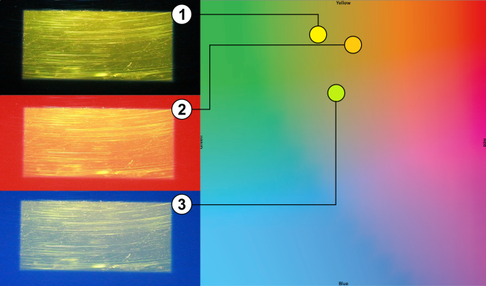

Figure 2. Examples of color blending with a yellow rectangle on (1) no background – black, (2) red and (3) blue backgrounds for the p3700 display.

We propose a color correction algorithm based on the BP model and study it with on extensive set of background and foreground colors. Our results show digital colors are corrected more accurately for displays with limited color profiles. Moreover, the system corrects more digital colors when the backgrounds have low luminosity, becoming harder when the backgrounds have a high luminosity. For our display with the largest color profile, we show which sets of colors can be better corrected: light neutrals, cyan and blue.

In this paper we contribute to the field of augmented reality in several ways: 1) we introduce open-loop color correction for optical see-through displays and the binned-profile model; 2) we validate the BP model against other possible solutions; 3) we propose a color correction approach based on the BP model and studied it with a wide range of background and foreground colors; and 4) we discuss the design implications and the challenges associated to incorporating our approach into everyday optical see-through display platforms.

# Background And Scope

Color blending is the phenomenon where background light coming from real-world objects mixes with the light emitted by the display affecting the color users perceive. Figure 2-left shows examples of color blending for a yellow box over three different background conditions: no background (black), red and blue. Figure 2-right shows the corresponding shift in color: the yellow square shifts toward orange when the background is red and toward green when the background is blue[1]. Field studies of AR applications with optical see-through displays reveal that the clarity and legibility of digital colors are affected by such changes; i.e. the colors in text and icons are altered (change in hue) or washed out (de-saturation) [28]. Such changes affect the user interface and can render it useless: e.g. text might turn unreadable when washed out, or color encoded information such as red warning icons might lose their visual meaning.

Gabbard et al. studied such color changes in optical see-through displays [9] by building an experimental test-bed and examining foreground (27 colors on the edge of the RBG gamut) and background colors (6 common outdoor colors – foliage, brick, sidewalk, pavement, white and no background) of different lighting level and hues. Their results showed light background colors affect all other colors by pulling them towards white; while background colors of different hues pull all colors toward them. They defined the color blended and perceived by a user (CP) as a function of the light source (L1), the reflectance (RF) of background object (B), the light emitted by the display (L3), the interaction of both L1 and L3 in the display (ARD), and the human perception (HP). Equation 1 describes the interactions:



Figure 3. Left: The digital color #FF0000 (white border) and as displayed by different optical see-through displays. Right: The foliage color (white border) and as it is seen through different optical see-through displays.

$CP=HP\left({AR}_{D}\left(L_{3}, RF\left(L_{1}, B\right)\right)\right)$ (1)

Borrowing from spatial AR and projection systems, Weiland et al. address color blending in see-through displays by means of color correction [32]: carefully selecting the color shown by the display so that the resulting blend comes close to the color originally intended. Their solution is representative of a closed-loop approach, where the system shows an image, the image blends with the background, a camera captures the resulting blend, and the systems corrects colors in the image iteratively until the blend comes closest to the original. Such closed-loop systems rely on camera located at the user’s vantage point to capture the blended image. However, such solution is impractical for situations where the camera cannot be placed on a user’s vantage point like HMDs or transparent-display handheld devices.

We propose an open-loop approach where digital colors are corrected based on the current background color and a color blending model. To create such model we take equation 1 as our starting point and unwrap the interaction of colors on the display (ARD) to account for two externally observable distortions. The first distortion is due to the fact that each display renders digital colors differently, and that it is such rendered color the one to consider when estimating color blending. Figure 3-left shows the color red (#FF0000) as displayed by different screens. Figure 1 illustrates this distortion as the difference in hues between the “digital color” (DC) and the “color shown”. The second distortion is due to the display medium changing the background color before blending. Figure 3-right shows the foliage color as seen through different screens. Figure 1 illustrates this distortion as the difference in hues between the “bg color” and the “bg in display” color. In our formulation we simplify the light and reflectance of the background (the RF(L1,B) component of equation 1) into the single entity “background color” (BC). Moreover, we leave the influence of human perception of colors for future work. Thus, we model color blending as follows:

$Blended Color= f_{dDC}\left(DC\right)+ f_{dBC}\left(BC\right)$ (2)

Key to this model is the characterization of the fdDC and fdBC distortion functions. The fdDC function describes the way a particular display shows a given digital color and it is the scope of this paper: we propose the binned-profile model (see section 5), apply it for color correction and analyze its correction capacity on multiple sets of background and foreground colors (see section 6). The fdBC function describes the way the display medium alters a background color and it is out of the scope of this paper; instead we limit the backgrounds we used and collect objective measures of how they are seen through the display. Unveiling this function requires capturing real world background colors and creating a model of how the display medium affects (hue and luminance) them; without a camera at the user’s vantage point (see section 7 for possible solutions to this function).

# Related Work



Figure 4. Experimental test-bed. Top: Component diagram. Bottom-Left: Actual set-up with a projector display. Bottom-Right: Lenovo S800 mobile device – T-OLED display.

## User, Content and Hardware Solutions

Researchers have long discussed color blending as a significant perceptual challenge for the field of AR [20] especially in outdoor environments. Field studies of AR applications highlight that such inability to clearly see the display worsen with bright sunlight and with the sun lower in the sky [16]. In order to improve the display visibility users resort to strategies like looking for a dark spot (dark surface or shadow) or placing a hand in front of the display. Both strategies require users to switch context between their activity and the display and often missing important information. Strategies like these inspired researchers to investigate automatic ways to improve display clarity. A simple approach is to dynamically increase the intensity of the digital content (mentioned in [18]), however such solution is not always efficient [16]. Leykin and Tuceryan capture the field of view of the user and classify this image into zones where digital text would be readable or unreadable [21]. In a similar fashion, Tanaka et al. developed a layout system that relocates digital content to the darker areas of the display [31] taking into account restrictions like ordering of the components.

Color blending is also an important factor affecting the effective occlusion of physical objects by digital content; a feature particularly useful when the real environment is enhanced with 3D virtual objects that are intended to look real, such as in architectonical previewing. Without effective occlusion, the virtual object is perceived as translucent and unreal [6] and can confuse users [29]. Solving the occlusion problem keeps digital content from being affected by the physical objects in the background, thus solving the color blending problem. The main approach to solving occlusion has been to stop the light coming from the background by enhancing head-mounted displays with light blocking devices such as a transparent LCD [17][19][33] or spatial light modulators (SLM) [6]. In this approach a black/white depth mask of the scene is generated with the black pixels covering the area where digital content is not to mix with the background light. Therefore, digital colors projected on the black areas are seen in their original hue and lightness. Another solu-tion is to control the illumination of the physical objects in a way that areas behind digital content remain in the dark. Noda et al. explored this approach by constraining physical objects to a dark room [27], while Bimber and Frölich implement it via occlusion shadows in a virtual showcase [3]. Finally, occlusion support has also been achieved in spatial AR by placing the parts of the optical system behind the augmented object, such as Inami et al.’s usage of retro-reflective material as optical camouflage [15].

Our approach differs from these kinds of solutions as we aim not to change the location of user interface elements and not to add new hardware components to the see-through display; rather we seek to manipulate the color shown by the see-through display; an approach known as colorimetric compensation or color correction.

## Color Correction Solutions

The field of projector-based spatial AR studied color correction as a way to enable projections on non-white or textured surfaces. Nayar et al. proposed a camera-based radiometric calibration model to compute the relation between the digital image and the projection on a textured surface [26]. Their approach requires a calibration phase where known patterns are projected on the projection surface and the resulting blended images are processed to obtain compensation matrixes. Bimber et al.extended the range of projectable color by using a transparent film and multiple projectors taking into account the reflectance and absorption of the digital color by the projection surface [5]. Grossberg et al. extended the radiometric model to include ambient light [11]. While these works deals primarily in device dependent RGB space, others achieved higher correction accuracy by working on the device independent CIE XYZ color space [1][24]. Weiland et al. applied colorimetric compensation to see-through displays, and proposed a subtraction compensation model which is based on both color differences and the human eyes adaptive range [32]. Color correction approaches have shown good compensation results (mostly qualitatively through images), but are limited to rather static digital content and background settings. Common to all of these approaches is the usage of a camera to capture the blended image and iterative color corrections configuring closed-loop system.

In this paper we continue the color correction line of work with see-through displays but propose the usage of open-loop systems. Our work walks away from color subtraction and focuses on the actual colors our displays can show. We proposed the binned-profile model, an approach which uses a display profile for foreground colors, and considers background colors as seen through the display. Moreover, we use the device independent CIE XYZ and CIE LAB color spaces, extend our study to both projector-based and T-OLED displays, and present results quantitatively.

# Experimental Test-Bed

We designed and built an experimental test-bed to generate background colors at different lighting conditions, show colors on multiple see-through displays, and measure the resulting color blending (Figure 4).

To generate different backgrounds we use a Dell U2312HM VGA LCD display calibrated at the standard D65 white point, a white that reproduces the color spectrum as it exists outdoors. This approach to generating background colors is limited by the color gamut of the LCD. Our test-bed takes distance from previous systems [9] which prioritize the capacity to obtain background colors as seem in nature; our design prioritizes the capacity to automatically produce a wide variety of background colors. For our experiments we used background colors from the Macbeth color chart, as they mimic those colors of everyday natural objects like skin color, foliage and flowers. Figure 6A shows the difference between the theoretical background colors and the ones produced and captured in our test-bed.

|  |  |  |  |  |  |
| --- | --- | --- | --- | --- | --- |
|  |  | p2200 | P3700 | T-OLED |  |
| No BG | X Y Z | 0.2655720  0.282182  0.481033 | 0.9504  1  1.0888 | 0.383264  0.395001  0.369982 |  |
| White | X Y Z | 0.9504  0.990041  1.0888 | 0.9504  1  1.0888 | 0.724775  0.759896  0.727336 |  |

Table 1: White points for all three optical see-through displays.

Our test-bed works with three optical see-through displays: two projector-based and one transparent OLED. The projector-based displays use a 3 mm transparent acrylic surface covered with a Lumisty MFY 2555 film and one of two projectors at 40°. The first projector is an Epson 1705 at 2200 lumens, hereafter called the p2200 display. The second projector is an Epson VS35ow at 3700 lumens, hereafter called the p3700 display. For the transparent OLED display we used a Lenovo S800 phone [12] which has a 240x320 transparent OLED display at 167 ppi, hereafter called the T-OLED display. The T-OLED display is covered in acrylic and with a total 9 mm thickness. The test-bed holds the displays at 20 cm in front of the background LCD.

To examine the background and digital colors and the resulting color blends we used the notations of the *Commision Internationale de l’Éclairage* (CIE) color model. We use the CIE 1931 XYZ color space for color measurement and addition required by equation 2. However the XYZ color space resembles the working of the human visual system which is more sensitive to colors in the blue or green hours. Therefore, we used the CIE 1976 Lab color space, a perceptually uniform color space, to calculate the perceptual difference between colors; e.g. the distance between a color and its shift when blended, or the distance between a prediction and the measured blend.

To collect data we used a Konica Minolta CS-200 luminance and color meter at a 0.2 degrees angle (standard observer angle). For both p2200 and p3700 displays we measured the XYZ white points of the Lumisty surface at 5 different points: one near the each of the display’s four corners and one in the center. For both projectors all measurements of the white point remained the same. Based on these results we located the colorimeter at 20 cm away from the see-through and at the center of the display. The colorimeter measures colors in the XYZ color space and we converted these values into a normalized LAB space using the appropriate white point for each case. After calibrating the background LCD to the D65 white point (measured at 0.9504, 1, 1.0888) we measured two combinations of the white points per display and recorded the average of 100 measures per combination (see Table 1):

1. See-through showing white and bg LCD turned off.
2. Both see-through and bg LCD showing white.

All displays and colorimeter are connected to the same controlling computer and are kept from any outside light by an enclosure (represented in Figure 4 as the dark cave).

# The Binned-Profile Model

In order to build an open-loop color correction system, it is necessary to have a model of the resulting blend for a given pair of background and foreground colors on a particular display. Providing such estimation requires unveiling the fdDC and fdBC distortion functions of equation 2.

In this paper we propose a model of the fdDC distortion function called the binned-profile (BP) model. The BP model divides the RGB color space (over 16 million colors) into a smaller set of perceptually different bins (8376 bins). To create the bins we translate the RGB gammut into the CIE LAB color space, and divided it into into boxes of 5×5×5 – a method proposed by Heer and Stone [13] which guarantees all colors inside the box are within one noticeable difference; i.e. they are perceived as the same color by a human observer [22]. Figure 5A-B shows the RGB gamut on the CIELAB color space and the binned result. Then, we measured how each bin is shown by each of our three display devices. We turned off the background LCD and measured the display reproduction of the whole binned RBG gamut (8376 colors) for each of our displays. Each color was captured using the colorimeter and the captured XYZ values where transferred into the CIE LAB color space by using the reference white points given in the Table 1 (top row). Based on these measurements we created a look-up table for each display. Figure 5C-E presents the profile for each display with the p3700 matching the binned space almost perfectly (C), and considerable reductions of color capacity for the p2200 (D) and T-OLED displays (E).



Figure 5. (A) RGB gamut on the LAB color space, (B) the binned gamut, and the binned profile for the (C) p3700 and (D) p2200 projector-based displays, and for (E) for the T-OLED display.

We use each display profile as the core element of the fdDC function. To find out how a display represents a digital color we first translate the display color to its closest bin in LAB space and use the latest as a key in the lookup table. We use the color associated with the key as the one the display actually shows (Color Shown in Figure 1).

## Binned-Profile Model Validation

In order to assess the validity of BP model for a future color correction system, we explore its capacity to predict color bending and compare it to other approaches. Prediction happens by adding the color given by the fdDC to the background and comparing it to the measured blend. Listing 1 presents how we used the BP model for color prediction. We compare the prediction accuracy of our model against the direct model (DM) and three chromatic adaptation transformation models (CAT). Listing 2 presents the direct model, where the digital color is simply added to the background. Chromatic adaptation transformation is an established method to estimate the actual colors a display can reproduce based on the brightest white it can emit. In other words, CAT could potentially account for the fdDC distortion function of see-through displays. CAT is based on matrices and researchers have proposed CAT models which rely on different matrices. Listing 3 presents how we used CAT models for our blending predictions; we transformed the foreground color using the respective CAT matrix before adding it to the background. We chose three popular CAT models for our exploration on color blending: Bradford [30], Von Kries [30], and XYZ Scaling [8]. We selected those models due to their popularity in the literature and as a representative set of their kind.

BP_prediction(display, foreground, background)

binned_foreground = findBin(foreground)

display_foreground = lookup(display , binned_foreground)

prediction = addXYZ(display_foreground, background)

**return** prediction

Listing 1. Binned-Profile prediction algorithm

DM_prediction(foreground, background)

prediction = addXYZ(foreground, background)

**return** prediction

Listing 2. Direct model prediction algorithm

CAT_prediction(CATmatrix, foreground, background)

cat_foreground = foreground × CATmatrix

prediction = addXYZ(cat_foreground, background)

**return** prediction

Listing 3. CAT model prediction algorithm

As discussed before measuring the background color and characterizing the effect of the second distortion (fdBC function) is out of the scope of this paper. We work under that assumption that such color is available at a per-pixel level. However, for the sake of discussion, we compare two possible camera-based background detection implementations: *pure* and *distorted*. The background color is *pure* if the system ignores the effect of the second distortion and feeds it to the system as it is measured, so that $f_{dBC}\left(background\right)=background$. The background color is *distorted* is the system accounts for the second distortion and transforms the color before feeding it to the system (see *Bg Color in Display* in Figure 1).

We considered 23 of the ColorChecker Color Rendition Chart [23] at D65, a representative set of naturally occurring colors (the 24th ColorChecker color is outside the RGB gamut). We measured the colors as shown by the background LCD. These values correspond to the *pure* background configuration (see Figure 6A). We also measured how each background color would be seen through the see-through displays (see Figure 6B-C). These values correspond to the *distorted* background configuration for each display. For the background LCD there is a displacement in *a* and *b,* however the *L* remains stable with an average change of 1.56 units in LAB; this means the background LCD displays the ColorChecker colors in a way that resembles how they are normally seem in nature. For the see-through displays the data shows displacement in *a* and *b*, but also a considerable reduction of *L*; this is due to the display material absorbing some of the light from the background. Note the significant impact of the T-OLED display on all axes.

## Data Collection

In order to access the prediction accuracy of the BP model and compare with the other models (CM and CATs) under the two background configurations (*pure* and *distorted*), we collected a large set of actual color blends. We used the 23 ColorChecker colors for backgrounds and 838 random foreground colors (10% of the size of the bin). We measured the resulting blending for each of our three displays capturing a total of 23×838 = 19.274 measurements per display and 19.274×3 = 57.822 measurements in total. We converted the blending measurements into CIE LAB using the white points from table 1. At the same time we predicted the resulting color blend according to the algorithms in listings 1-3 for each combination of prediction model (5), background configuration (2) and display (3). We obtained 5×2 = 10 predictions per blending, 5×2×23×838 = 192.740 predictions per display, to a total of 192.740×3 = 570.822.



Figure 6. ColorChecker bg color set as (A) shown by the background LCD, (B) as seen through the p2200 and p3700 displays, and (C) as seen through the T-OLED display. The bigger circles represent the original color, the smaller circle how it is measured in each condition.

We computed the accuracy of the predictions by calculating the Euclidian distance in CIA LAB color space between each prediction and the actual measurement.

## Results

Given the wealth of data we collected we first introduce different visualizations we use for our data analysis. Figure 9 shows the prediction results for a random sample set on the foliage background color, on the p3700 display, with the *pure* background configuration, using the direct model. Figure 9A shows the prediction accuracy as a 3D shape in LAB space with more accurate predictions in dark red and less accurate ones in light yellow; the location of the points corresponds to the profile of the display. This 3D figure is instrumental in understanding which color areas are better predicted than others. However, it’s hard to draw general conclusions about the prediction accuracy. Figure 9B shows a histogram of the same data points sorted by accuracy. More accurate predictions piled up at the bottom near to zero, while less accurate predictions spread to the top. Figure 9C is a top view of this histogram with zero close to the bottom of the graph and color intensity representing the height of the histogram. We use these vertical histograms to analyze the results of our prediction study. Figure 7 presents different colors that differ from the first one linearly and the magnitude of this difference in Euclidian distances and JNDs. For example, the best prediction in Figure 9 is at an Euclician distance of 0.9 (less than 1 JND), similar to distance to the first square in Figure 7; while the worst prediction is at an Euclician distance of 69.89 (30 JNDs), similar to the distance to the fifth square in Figure 7 (i.e. the estimation was that much off).

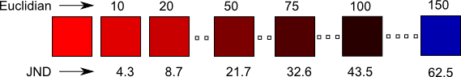

Figure 7. Examples of Euclidian distances and their corres-ponding just-noticeable difference. 2.3 = 1 JND. Best in color.

Figure 8 summarizes the results for our prediction study using vertical histograms. A visual inspection of the results shows that for all conditions the CAT models performed worst, with a high spread in the accuracy and average far from optimal (in the case of the p3700 display, the CAT models all perform the same due to the fact that the white point of this display is exactly D65). Thus we exclude the CAT models from the rest of this analysis.

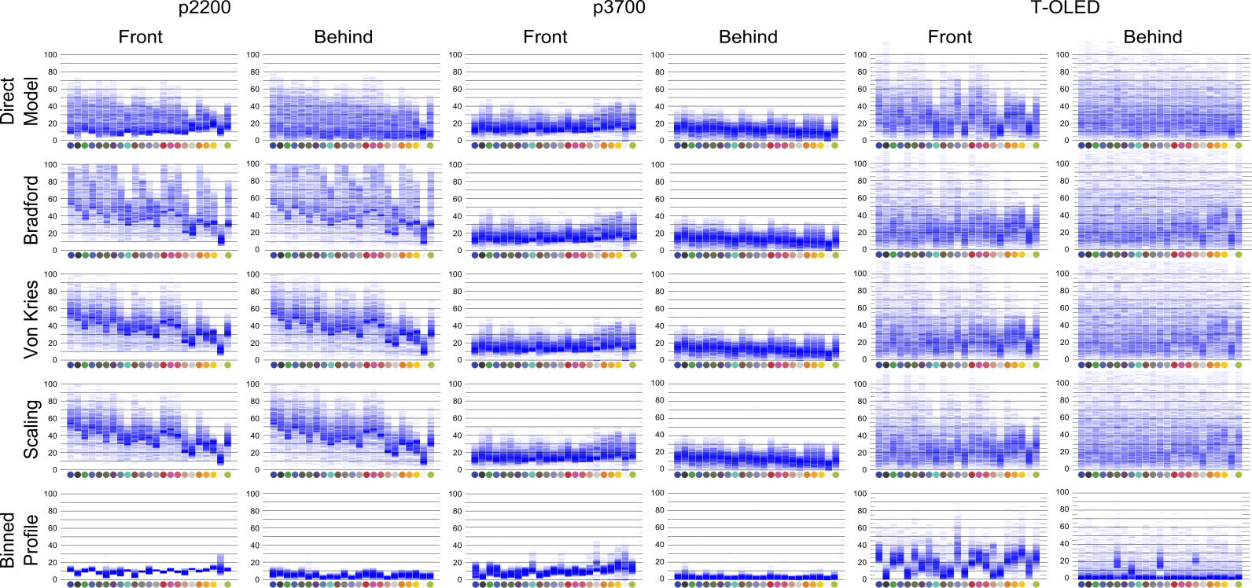

Figure 8. Prediction results for the p2200, p3700 and T-OLED displays, with 5 prediction models, and *front* and *behind* background configurations.

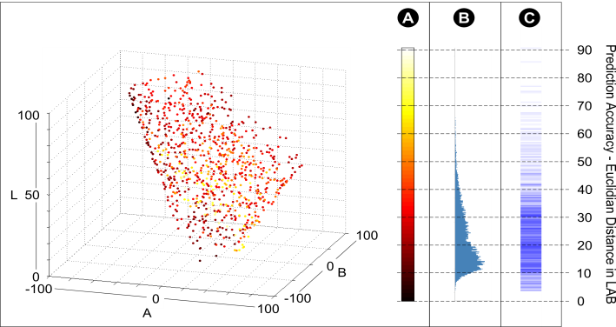

Figure 9. Single prediction result. A) Accuracy per color in LAB; B-C) Histograms of the accuracy for the whole sample.

For the p2200 display the BP model performed best in each background configuration (*pure*: 10.01 avg. dist., 2.74 std. dev. – *distorted*: 4.96 avg. dist., 2.40 std. dev.). The DM model also presented, even if subtler, a different between background configurations (*pure*: 22.81 avg. dist., 12.31 std. dev. – *distorted*: 22.16 avg. dist., 15.08 std. dev.). We observe a similar pattern for the p3700 display where the BP model has higher prediction accuracy for both background configurations (*pure*: 10.28 avg. dist., 5.39 std. dev. – *distorted*: 2.77 avg. dist., 1.9 std. dev.) than the DM model (*pure*: 17.5 avg. dist., 7.27 std. dev. – *distorted*: 13.67 avg. dist., 6.43 std. dev.). Finally, when applied to the T-OLED display the BP model also performed with higher accuracy for both background configurations (*pure*: 25.87 avg. dist., 10.91 std. dev. – *distorted*: 8.98 avg. dist., 11.94 std. dev.) than the DM model (*pure*: 34.84 avg. dist., 13.39 std. dev. – *distorted*: 32.95 avg. dist., 18.90 std. dev.). [ANOVA ON Model X Background X Display].

Overall, results show the binned-profile model consistently outperforms the other prediction models we tested across all 23 background colors. Moreover, this high accuracy exists for both the *pure* and *distorted* background configurations. Our results stress out the importance of the first display distortion (how the display represents digital color) as the dominant factor for color blending. More importantly, our results highlight the limitations of the direct model (ignoring the display distortion) and the inadequacy of any of the three CAT models we tested. Finally, our results show that considering the second distortion improves prediction accuracy, reducing the error by more than half in all displays. For the p3700 display prediction accuracy of the BP model with the *distorted* background condition was of 2.77 or about 1 just noticeable difference – a very accurate result.

# Color Correction

Color correction aims at finding an alternative color which, upon mixing with the background, results on the color originally desired by the designer. In this section we propose an open-loop color correction approach for optical see-through displays based on the BP model as explored in section 5.

When correcting a color for a given background, the system predicts how each color of the display profile blends with such background, finding a color which prediction comes the closest to the originally intended color. This algorithm is described in Listing 4. First, the foreground color (*foreground* - the RGB color the system wants to paint on the screen) is mapped to the closest of the binned RGB colors (*binned_foreground* - see Figure 5B). Second, based on the display profile, the binned color is mapped to its actual representation (*display_foreground* - the way such binned color is actually shown by the display). Third, for each color on the display profile, the system predicts its blending with the background (*prediction*) and measures the distance between the prediction and the display color (*tmp_accuracy*). The system selects the display color with the highest accuracy (*color_to_show*) and converts it to the corresponding binned color that produces it via a reverse lookup on the display profile (*corrected_color*). Finally the display shows the corrected color.

BP_preservation(display, foreground, background)

binned_foreground = findBin(foreground)

display_foreground = lookup(display , binned_foreground)

accuracy = INFINITY

**foreach** color **in** display

prediction = addXYZ(color, background)

tmp_accuracy = distance(prediction, display_foreground)

**if** tmp_accuracy < accuracy

accuracy = tmp_accuracy

color_to_show = color

corrected_color = reverseLookup(display, color_to_show)

**return** corrected_color

Listing 4. Binned-Profile color correction algorithm.

It’s important to note that our algorithm aims at correcting the color the display actually shows, rather than the application defined foreground. Moreover, our algorithm avoids using color subtraction (corrected_color = foreground - background) for two reasons: first, similarly to the direct model for color prediction, color subtraction ignores the particular display profile leading to an incorrect target for correction. Second, because color subtraction often results in values for corrected_color which are outside the display profile.

## Data Collection

In this study our goal is to explore how well the algorithm corrects foreground colors for different common backgrounds. We applied the color correction algorithm on the p3700, p2200 and T-OLED see-through displays for the 23 ColorCheck backgrounds in their *distorted* version. We selected 200 random foreground colors for each background, corrected them, and measured the distance between the *display_foreground* and the resulting color amounting to 23×200= 4600 measures per background. We collected data on all three displays, for a total of 23×200×3=13800 measurements.

We took a two-step approach to analyzing the collected data. In the first step we looked at the general correction capacity of the algorithm for the three displays. In the second step we focused on the p3700 display as it can reproduce a wider variety of colors (see Figure 5C-E for the color profile of each display). For this display we grouped the foreground colors into 10 groups: dark colors (L < 50), light colors (L > 50), dark and light neutrals (neutrals are located within 10 JNDs of the L axis, dark L < 50, light L > 50), and 6 chromatic groups according to the color circle. Figure 10 shows (left) the dark and light neutrals, and (right) the chromatic groups in the color circle. Note that each foreground might belong to more than one group. Similarly, we divided the ColorCheck backgrounds into *high intensity* resembling daylight conditions like white and yellows, and *low intensity* resembling night conditions like black and blue. Figure 11 shows the background color groups we created[2].

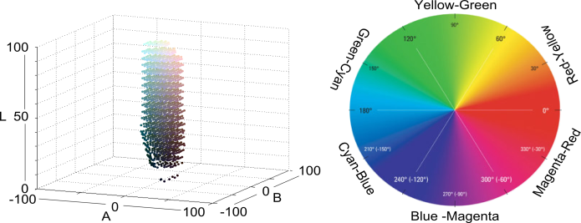

Figure 10. Foreground color groups. Left: neutral colors within 10 JNDs from the L axis. Right: 6 chromatic groups according to the color circle – YellowGreen, GreenCyan, CyanBlue, BlueMagenta, MagentaRed and RedYellow.

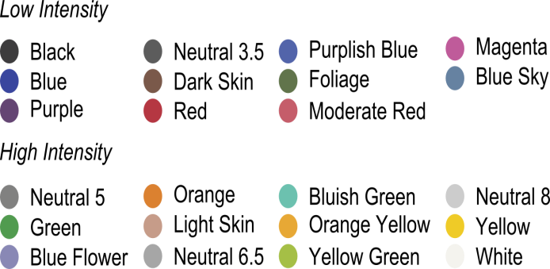

Figure 11. Groups of background colors.

## Results

For analyzing the correction results we used the vertical histograms together with a color heat-map (see Figure 12-Top-Right). The color heat-map reveals how well groups of foreground colors can be corrected for a given set of background colors. The color heat-map divides the 2D AB color map into a 30×30 grid. Each grid cell is colored in blue (#0000FF) with the opacity moving from 0 to 1, where the opacity is relative to the average correction accuracy (ranging from 0 to 100+) of all colors in that cell. If the sample did not contain corrections for foreground colors in a given cell, the cell has no blue box. If the sample contains corrections for a given cell, the accuracy of each correction is calculated and averaged with the rest. Cells in which colors are well corrected in average result in a faint blue. Cells in which colors cannot be corrected in average result in a dark blue.

Figure 12 shows the general correction accuracy results for all background and foregrounds colors on the three displays. A visual inspection of the results reveals that correction works better for low luminosity backgrounds (toward the left of the vertical histogram) for all three displays. Results also show corrections are more accurate for the p2200 and T-OLED displays (fainter blue boxes in the heat-map and more concentrated vertical histograms). This could be explained by the limited range of colors they can render (concentrated in a small volume in the LAB color space) and therefore the distance between the measured correction and the target color will always be small. Conversely, corrections are less accurate for the p3700 display; which can be explained by its wider range of colors (occupying a larger volume in the LAB color space) and therefore the distance between the measured correction and the target is larger. Finally, foreground colors toward the edge of the gamut (red, green, blue) are generally less well corrected than colors located in the central region of the gamut.

Figure 13 shows the correction results for the p3700 display according to high and low intensity backgrounds and the different foreground groups. A visual inspection of Figure 13 shows that BP-based color correction for the p3700 display works best on low intensity (dark) background colors. This is the case for all groups of foreground colors with seemingly better performance in the light foregrounds. For high intensity (light) backgrounds we observed a decreased correction capacity across all foreground colors, and a particularly acute decrease on dark foregrounds and on the outer areas of all color groups (more saturated colors). We also observed that the region of neutral colors might be larger than we originally thought as similar levels of correction accuracy might be found at a bigger radius. For both background conditions the light neutrals present lighter heat-maps.



Figure 12. Correction results general

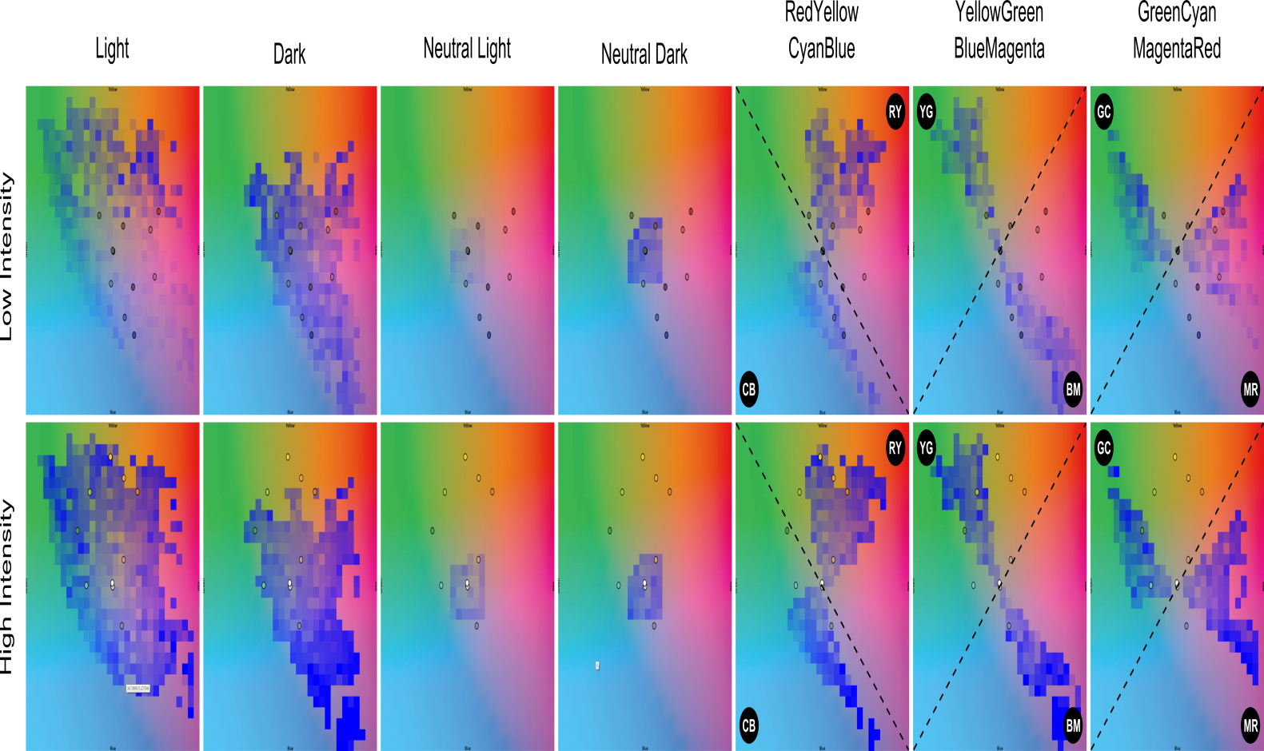

Figure 13. Correction results for the p3700 display of the groups of foreground colors according to high and low intensity backgrounds.

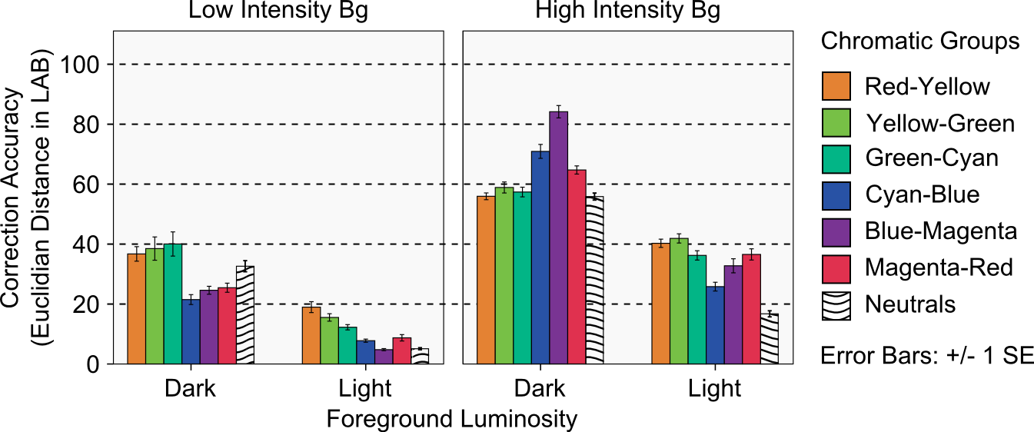

Figure 14. Quantitative analysis of correction accuracy using the BP model for the p3700 display.

Figure 14 gives a quantitative view of the correction accuracy for the chromatic groups and the neutrals for the p3700 display. We used two univariate ANOVA tests and the Bonferroni correction for post-hoc pair-wise tests for our analysis. The first ANOVA looked into the accuracy differences between *background intensity*, *foreground luminosity* and *chromatic groups*. Given that neutrals can belong to any chromatic group, our second ANOVA look only into the accuracy differences of neutrals colors between the *background intensity* and *foreground luminosity* conditions.

*Chromatic Color Groups* – Results showed a main effect of *back-ground intensity*, *foreground luminosity* and *chromatic group* (all p < 0.001) on correction accuracy with F1 = 1151.52, F1 = 827.28, and F5 = 6.88 respectively. There were significant interaction effects for *background intensity* × *foreground luminosity* (F1 = 33.43, p < 0.001), *background intensity* × *chromatic group* (F5 = 21.13, p < 0.001), *foreground luminosity* × *chromatic group* (F5 = 11.98, p < 0.001), and *background intensity* × *foreground lumino-sity* × *chromatic group* (F5 = 17.78, p < 0.001). Post-hoc pair wise comparisons of *chromatic groups* yielded significant differences between BlueMagenta and all other groups, between RedYellow and GreenCyan and CyanBlue, and between CyanBlue and MagentaRed. In general corrections were more accurate for low intensity backgrounds at 21.23 (9.2 JNDs), for light foregrounds at 23.46 (10 JNDs), and the CyanBlue group at 31.49 (13.6 JNDs).

*Neutral Colors* – Results showed a main effect of *back-ground intensity* and *foreground luminosity* (all p < 0.001) on correction accuracy with F1 = 197.2 and F1 = 714.2 respectively. There were significant interaction effects for *background intensity* × *foreground luminosity* (F1 = 21.9, p < 0.001). In general corrections were more accurate for the low intensity backgrounds at 18.81 (8.1 JNDs) and for light neutrals at 10.91 (4.74 JNDs).

Overall, results show that colors can be better corrected for displays with a lower color capacity as we have shown for the p2200 and T-OLED displays. This can be explained by the fact that the display profile is a small volume and therefore distances between the corrected color and the originally intended will always be short. The trade-off is that such displays cannot really convey realistic color experiences. More interesting are the results for the p3700 display, a display with a larger color profile as you would expect in a general purpose multimedia device. This results show that the BP-model can achieve highly accurate corrections for low intensity backgrounds (such as the ones in dark environments or night conditions), particularly for light colors on the display. Moreover, for high intensity backgrounds (such as the ones in daylight conditions) the BP-model achieves its best corrections for light foregrounds, particularly for the neutrals and the colors of the CyanBlue family. Finally, the BP-model presents a consistently low accuracy for correcting dark foregrounds, with opposite trends depending on the background. For low intensity backgrounds CyanBlue, BlueMagenta and MagentaRed are corrected best, however, for high intensity backgrounds it is RedYellow, YellowGreen, GreenCyan and the neutrals that are corrected best.

# General Discussion

Our Aim in this work was to look into the factors that are influencing color blending and to preserve the digital colors being influenced by the background. On arriving at algorithm that can preserve color under almost ideal situations, we have shown degree to which colors can be preserved under varying background conditions. In this section we would like to discuss the impact of our findings with focus on wider adaptation of see-through displays to view legible contents.

One of major influencing factor which was very evident based on the compensation data was the role of intensity (L value) of the colors. As shown in the figure 8, most colors which are preserved well irrespective of the background or the display where the colors in hue neutral high intensity region (color near white) in LAB space. Another major factor was the intensity of the background colors. In the figure 8 the compensation on s800’s OLED screen was better than p2200 and p3700. The background when passing through the s800 display lost almost half its original intensity. This chance in L value is shown in figure 9, it is to be noted that the in all cases the change in background’s hue was found to be very minimal, however the change in intensity was found to be significant.

With recent development in augmented reality hardware see-through displays in being used for every day actives like GPS navigation [], social networking [], Museum[]. In all these scenarios the user interface requires color constancy for the content to be legible and readable. Based on our results it becomes clear preserving color in see-though display is dependent on various factors. Even on taking factors such as display distortion and background distortion into consideration it still can be impossible to correct all the colors. There are various reason for this We envision that content design for see-though display needs to be designed based on themes. For example as shown in the figure 8, most colors which are preserved well irrespective of the background are in the so called hue neutral colors or the color near white in LAB space. The data from the compensation indicates that

As in existing AR systems [32][5][18] we expect a system with color correction to use a camera to capture the background and map its colors to particular pixels in the display as input for the correction algorithm. Although the fidelity of such camera-based color capture is beyond the scope of the present paper [XXX], we work under the assumption that a camera could capture the real nature of background colors.

-------------------

Colors that can be corrected regardless of the background - Camera-based color correction

Closed look approaches might not be possible in HMDs because of the human face configuration (the camera would have to be located where the eye is located to capture both the screen content and the background). Therefore a *front* approach could also be used with similarly good results.

For spatial AR (where the location is known) a 3D model of the background could exist and projection of the lighting for a given perspective could be calculated real time before correction.

# Conclusions

This paper presents an open-loop approach to color correction in optical see-through displays based on two color distortions introduced by the display medium: a distortion in the way the display represents colors and a distortion on the background color before it blends with the color on the display. The paper focuses on addressing the first distortion and proposes the Binned-Profile (BP) model, a colorimetric model of how a particular display renders a representative set of colors of the RGB gamut. For the second distortion we used colorimetric measurements of how background colors are seem through the display medium. We validated the BP-model by measuring the accuracy of its color blend predictions on three different optical see-through displays against other known methods. The results showed that the BP model outperforms other methods, and that this first distortion is the main factor to address for correct color blend predictions.

We presented a color correction algorithm based on the display color profile of the BP-model and investigated its correction capacity using a wide variety of background and foreground colors for our three displays. Results showed BP-based color correction works best for displays with low color capacity. Moreover, for displays with high color capacity results show that colors can be better corrected for low intensity backgrounds, and that for high intensity backgrounds light neutrals colors and CyanBlue colors can be corrected best. We reported our results both graphically (through vertical histograms and heat-maps) and quantitatively.

We finalized with a discussion on the applicability of open-loop color correction and the BP model, some ideas about addressing the second distortion, and an outline of our future work.

References

1. Ashdown, M., Okabe, T., Sato, I., Sato, Y. 2006. Robust Content-Dependent Photometric Projector Compensation. In Proc. CVPRW '06. Vol. 6, No 6, PP 17-22.
2. Azuma, R., Baillot, Y., Behringer, R., Feiner, S., Julier, S., and MacIntyre, B. 2001. Recent Advances in Augmented Reality. IEEE Comput. Graph. Appl. 21, 6.
3. Bimber, O., and Fröhlich, B. 2002. Occlusion Shadows: Using Projected Light to Generate Realistic Occlusion Effects for View-Dependent Optical See-Through Displays. In Proc. ISMAR '02.
4. Bimber, O. and Raskar, R. 2005. Spatial Augmented Reality: Merging Real and Virtual Worlds. A. K. Peters, Ltd., Natick, USA.
5. Bimber, O., Emmerling, A., and Klemmer. T. Embedded Entertain-ment with Smart Projectors. IEEE Computer, 38(1):48–55, 2005.
6. Cakmakci, O., Ha, Y., and Rolland, J.P. 2004. A Compact Optical See-Through Head-Worn Display with Occlusion Support. In Proc. ISMAR '04. IEEE.
7. Carmigniani, J., Furht, B., Anisetti, M., Ceravolo, P., Damiani, E., and Ivkovic, M. 2011. Augmented reality technologies, systems and applications. Multimedia Tools Appl. 51, 1.
8. Chromatic Adaptation. (2013, April 23). Chromatic Adaptation. (2009) [Website]. Retrived from http://www.brucelindbloom. com/index.html?Eqn_ChromAdapt.html
9. Epson Moverio, (2013, May 15). EPSON Moverio BT-100 - Android Powered Interactive Display - Epson America, Inc. (2012) [Website]. Retrieved from <http://www.epson.com/cgi-bin/Store/jsp/Moverio/Home.do?BV_UseBVCookie=yes>
10. Gabbard, J.L., Swan, J.E., Zedlitz, J., and Winchester, W.W. 2010. More than meets the eye: An engineering study to empirically examine the blending of real and virtual color spaces. In Proc. VR '10. IEEE.
11. Grossberg, M.D., Peri, H., Nayar, S.K., and Belhumeur, P.N. Making one object look like another: controlling appearance using a projector-camera system. 2004. In Proc. CVPR 2004.
12. GSM arena. (2013, March 19). Lenovo S800 – Full phone specifications. (2011) [Website]. Retrieved from <http://www.gsmarena.com/lenovo_s800-4862.php>.
13. Heer, J., and Stone, M. 2012. Color naming models for color selection, image editing and palette design. In Proc. CHI '12. ACM.
14. Hong,G. Luo,MR. and Rhodes,PA., 2001. A study of digital camera colorimetric characterisation based on polynomial modelling. Color Research and Application, 26(1), pp. 76-84.
15. Inami, M., Kawakami, N., Sekiguchi, D., Yanagida, Y., Maeda, T., and Tachi, S. 2000. Visuo-Haptic Display Using Head-Mounted Projector. In Proc. VR '00. IEEE.
16. Kerr, S.J., Rice, M.D., Teo, Y., Wan, M., Cheong, Y.L., Ng, J., Ng-Thamrin, L., Thura-Myo, T., and Wren, D. 2011. Wearable mobile augmented reality: evaluating outdoor user experience. In Proc. VRCAI '11. ACM.
17. Kiyokawa, K., Billinghurst, M., Campbell, B., and Woods, E. 2003. An Occlusion-Capable Optical See-through Head Mount Display for Supporting Co-located Collaboration. In Proc. ISMAR '03.
18. Kiyokawa, K., Kurata, Y., and Ohno, H. An optical see-through display for mutual occlusion with a real-time stereovision system, Computers & Graphics, Volume 25, Issue 5, October 2001, Pages 765-779.
19. Kiyokawa, K., Ohno, H., and Kurata, Y. 2002. Occlusive optical see-through displays in a collaborative setup. In Proc. SIGGRAPH '02. ACM.
20. Kruijff, E.; Swan, J.E.; Feiner, S., 2010. Perceptual issues in augmented reality revisited. In Proc. ISMAR’10. IEEE.
21. Leykin, A. and Tuceryan, M. 2004. Automatic Determination of Text Readability over Textured Backgrounds for Augmented Reality Systems. In Proc. ISMAR '04. IEEE.
22. Mahy, M., Eyckden, L.V. and Oosterlinck, A. Evaluation of uniform color spaces developed after the adoption of CIELAB and CIELUV. Color Res. Appl., vol. 19, no. 2, pp. 105–121, Apr. 1994.
23. McCamy, C. S., Marcus, H., and Davidson, J. G. (1976). "A Color-Rendition Chart". Journal of Applied Photographic Engineering 2(3). 95–99.
24. Menk, C., Koch, R. Interactive visualization technique for truthful color reproduction in spatial augmented reality applications. In Proc. ISMAR ’11. 26-29. Oct. 2011.
25. Mitsunaga, T., Nayar, S.K.. Radiometric self-calibration. Computer Vision and Pattern Recognition. 1999. IEEE Computer Society Conference on. , vol.1, no., pp., 380 Vol. 1, 1999.
26. Nayar, S. K., Peri, H., Grossberg, M. D., and B. P. N. A projection system with radiometric compensation for screen imperfections. In Proc. of International Workshop on Projector-Camera Systems, 2003.
27. Noda, S., Ban, Y., Sato, K., and Chihara, K. 1999. An Optical See-Through Mixed Reality Display with Realtime Rangefinder and an Active Pattern Light Source. Transactions of the Virtual Reality Society of Japan, 4(4), 665-670.
28. Pingel, T. J., & Clarke, K. C. Assessing the usability of a wearable computer system for outdoor pedestrian navigation. Autocarto 2005.
29. Sekuler, A.B. and Palmer. S.E. "Perception of partly occluded objects: A microgenetic analysis." Journal of Experimental Psychology: General 121.1 (1992): 95.
30. Susstrunk, S. E., Holm, J. M., & Finlayson, G. D. (2000, December). Chromatic adaptation performance of different RGB sensors. In Photonics West 2001-Electronic Imaging (pp. 172-183). International Society for Optics and Photonics.
31. Tanaka, K., Kishino, Y., Miyamae, M., Terada, T., and Nishio, S. 2008. An information layout method for an optical see-through head mounted display focusing on the viewability. In Proc. ISMAR '08. IEEE.
32. Weiland, C., Braun, A.K., and Heiden, W. 2009. Colorimetric and Photometric Compensation for Optical See-Through Displays. In Proc. UAHCI '09. Springer-Verlag.
33. Zhou, Y., Ma, J.T., Hao, Q., Wang, H., and Liu, X.P. 2007. A novel optical see-through head-mounted display with occlusion and intensity matching support. In Proc. Edutainment'07. Springer-Verlag, Berlin, Heidelberg, 56-62.

1. Throughout the paper we use this 2D color map for representing colors. This is a slice of the perceptually uniform LAB color space at L=D65; the horizontal axis maps to A and the vertical axis maps to B, both ranging from -100 to 100.
2. A deeper analysis of how groups of foreground colors are affected by the typical everyday backgrounds requires a more exhaustive categorization of the dominant colors in each setting. Moreover, such categorizations might be affected by factors like the season of the year, the local culture, or even the geographical location. A plausible way of attaining such groups of dominant background colors for a given scene entails capturing images of usage situations throughout the appropriate period of time and extracting such background colors from them.